**Template for ICADA Papers**

Name SURNAME 1, Name SURNAME 2,*, Name SURNAME 3

1 Department, University, Country, e-mail address

2 Department, University, Country, e-mail address

3 Department, Company, Country, e-mail address

**Abstract**

The abstract should be short and at most 250 words. The format is a single column using 11 pt Times New Roman font, and justified.

***Keywords: Keyword 1; keyword 2; keyword 3; keyword 4.*** *(Enter keywords in alphabetical order, separated by commas, and conclude with a period. Minimum 3 and maximum 5 keywords should be provided.)*

# 1. Introduction

The International Conference on Artificial Intelligence and Data Science (ICADA) is an international scientific conference. The aim of ICADA is to bring together interdisciplinary research in the fields of artificial intelligence and data science.

# 2. Paper Organization and Format

## 2.1. Length and organization

Articles should not exceed 4 pages and should include following (or similar) sections: introduction, purpose, material and method, findings, results and recommendations.

## 2.2. Fonts and dimensions

The paper dimension should be A4. The following margins are used in the paper layout: Top: 2.5 cm; Left: 2 cm; Bottom: 2 cm; Right: 1.5 cm.

The format is single column. The text should be prepared in Times New Roman typeface, 11 pt, and justified. The first line of each paragraph should have 0.5 cm indentation.

For special parts of the paper the following text style should be used:

* Paper title: Times New Roman, 14 pt, bold, aligned centered, first character of each word is capitalized.
* Header 1: Times New Roman, 11 pt, bold, aligned left, first character of each word is capitalized, numbered (1, 2, …).
* Header 2: Times New Roman, 11 pt, bold, aligned left, only the first character of the first word is capitalized, numbered (1.1, 1.2, …).
* Header 3: Times New Roman, 11 pt, underlined, italic, aligned left, only the first character of the first word is capitalized, numbered (1.1.1, 1.1.2, …).
* Before each header add 12 pt, and after each header add 6 pt spacing.
* For sections such as Acknowledgements, References, and Appendix use the header 1 style without numbering.

## 2.3 Tables and figures

All tables and figures must be of high quality, readable and good use of page layout. Tables, figures, and their captions are centered. Font size of table and figure captions should be 10 pt. Table contents should also be centered and the font size should be 8 or 9. Table and figure labels should be bold (See Table 1 and Figure 1).

## 2.4. Equations

Equations are centered with center tab. Equation number is given in parenthesis. Justify all equation numbers using a right tab; do not use left tabs, spaces, or tables. You can refer to specific equations using the abbreviation “Eq. (1)”, “Eqs. (2), (4) and (5)” and “Eqs. (2)-(5)”.

See sample equation below:

$A={πr}^{2}$ (1)

where, A denotes the area and r is the radius of a circle.

# 2.5. Citation and references

For citation and references please follow the [IEEE Citation and Reference Style](http://ieee-dataport.org/sites/default/files/analysis/27/IEEE%20Citation%20Guidelines.pdf). Some examples are journal article [1], book [2], technical report [3], paper published in conference proceedings [4], general web site [5], and software [6].

**Table 1.** *Sample table.*

|  |  |  |  |  |
| --- | --- | --- | --- | --- |
| **Problem** | **Avg** | **Best** | **Worst** | **Std.** |
| P1 | 524.32 | 524.32 | 524.32 | 0.00 |
| P2 | 837.19 | 835.11 | 840.23 | 1.14 |
| P3 | 826.50 | 826.50 | 826.50 | 0.00 |
| P4 | 1028.26 | 1027.36 | 1029.44 | 0.55 |
| P5 | 1305.34 | 1305.34 | 1305.34 | 0.00 |

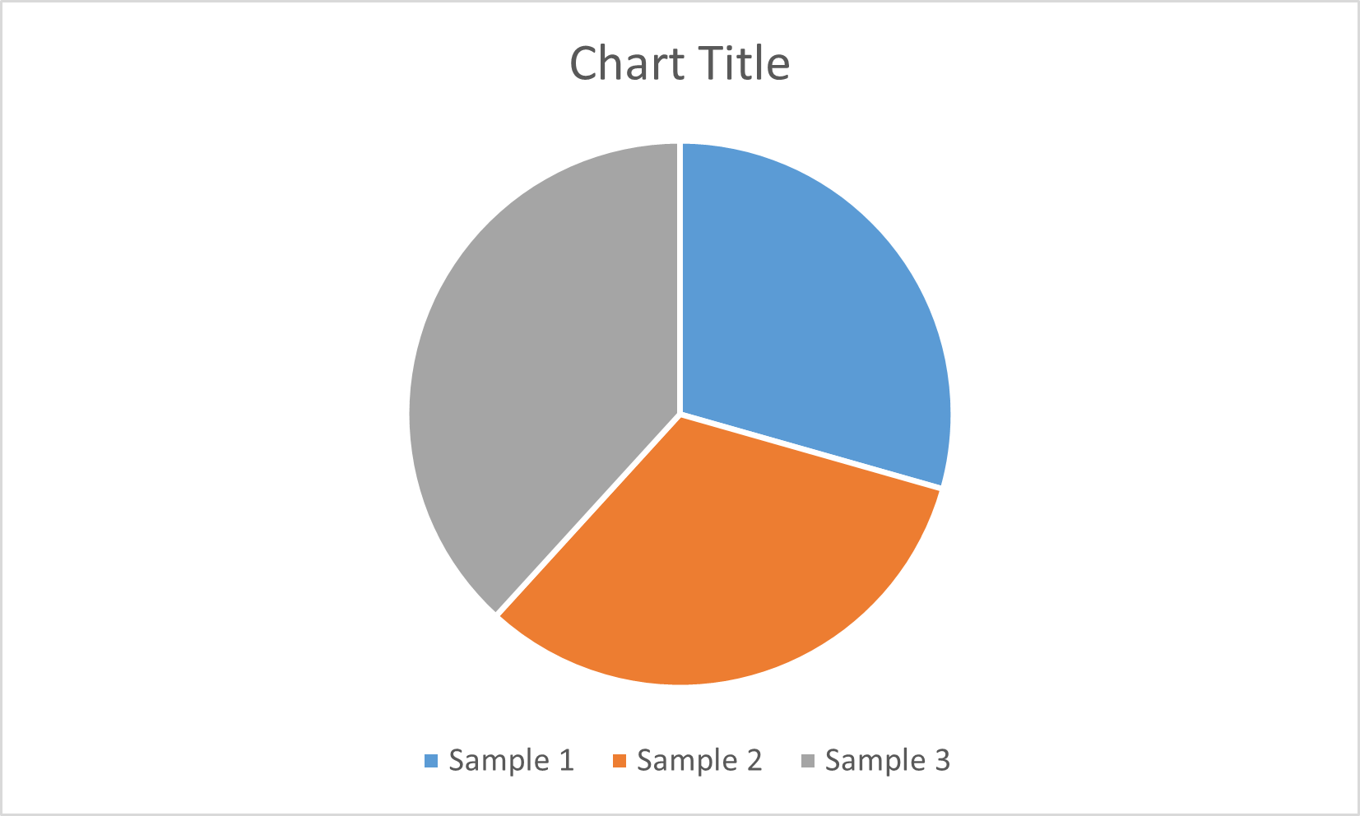

**Figure 1.** *Sample figure.*

# Acknowledgements

The authors acknowledge the support ….

# References

[1] K. A. Nelson, R. J. Davis, D. R. Lutz, and W. Smith, “Optical generation of tunable ultrasonic waves,” Journal of Applied Physics, vol. 53, no. 2, Feb., pp. 1144-1149, 2002.

[2] W. K. Chen, Linear Networks and Systems. Belmont, CA: WadsworthPress, 2003.

[3] K. E. Elliott and C. M. Greene, “A local adaptive protocol,” Argonne National Laboratory, Argonne, France, Tech. Report. 916-1010-BB, 7 Apr. 2007.

[4] J. Smith, R. Jones, and K. Trello, “Adaptive filtering in data communications with self improved error reference,” In Proc. IEEE International Conference on Wireless Communications ’04, 2004, pp. 65-68.

[5] J. Geralds, “Sega Ends Production of Dreamcast,” vnunet.com, para. 2, Jan. 31, 2007. [Online]. Available: http://nli.vnunet.com/news/1116995. [Accessed Sept. 12, 2007].

[6] Thomson ISI, Endnote 7. [CD-ROM]. Berkeley, CA: ISI ResearchSoft, 2006.